**Sprint – 4**

|  |  |
| --- | --- |
| Date | 04 November 2022 |
| Team ID | PNT2022TMID32303 |
| Project Name | Estimate the crop yield using Data Analytics |

**Exporting The Analytics:**

* Login to IBM Cognos then in open menu

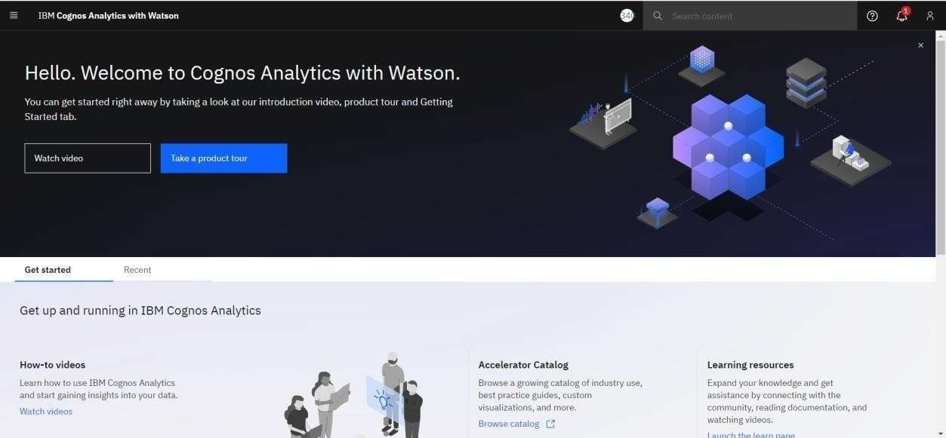

* Click on the **share icon**



* You can share using Email or Link or Export as pdf.

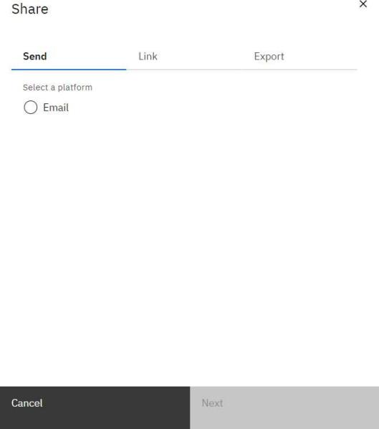

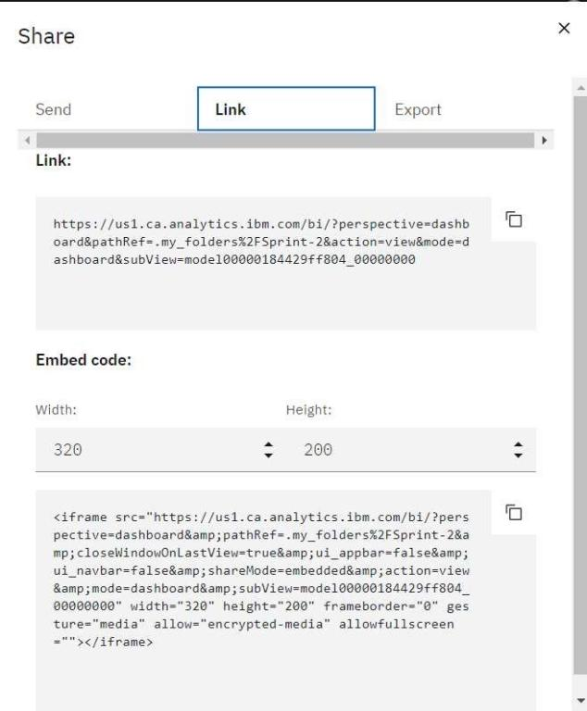

* Click the Export tab in the Share dialog box.
* You can change the page size and Orientation setting then click **Export**.

